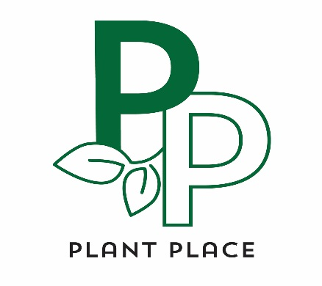
Donation Request Form
Please complete this form and submit it by mail or in person at least four weeks before your event.

Organization name________________________________________________

Tax ID #___________________________________________________________

Contact name____________________________Phone:__________________

Contact email_____________________________________________________

Mailing address___________________________________________________

Event name___________________________Event date_________________

How donation will be used (silent auction, prize, etc):_______________

__________________________________________________________________
Are the funds raised in this event targeted toward a specific use?

___________________________________________________________________

Plant Place Inc. PO Box 390 Elk River MN 55330 763-441-8022 www.plantplacemn.com
If your donation request is approved, we will be sending a gift card to use at our store.

